ME 200 – Thermodynamics, L. Liebenberg

**Name:** Joseph Specht Net-ID: jspecht3

**Quiz 2** (Total: 30 points) **Due back by Wed. 1 Feb. at 10 p.m., in Canvas**

* *This assignment pertains to Chapters 1 and 2 from your textbook.*
* *Explain all assumptions and show all calculations. Follow the problem-solving technique which we explored in Lecture Notes 2, wherever possible.*
* *Assignments will only be graded if the honor code statement is completed and signed.*
* *Save your entire assignment as one* ***PDF document*** *and upload it in the appropriate assignment folder on Canvas.*

Being a student of high standards, I pledge to embody   
the principles of *academic integrity*.

This quiz is my own work. I did not seek (or get) outside help or collaboration with any of the questions and their solutions. I did not post any of the questions on an electronic platform (like Chegg) nor did I solicit answers or solutions from any electronic platform (like Chegg). I also did not offer my solutions or answers to any other student.

I understand that this quiz is “open book” and “open notes” which means that I was permitted to use my prescribed textbook and lecture notes when addressing any of the questions. I have properly cited any other resources, with full cognizance of the regulations pertaining to plagiarism, copyright infringement, academic cheating, etc., as stipulated in the Student Code.

I acknowledge that academic violations will be dealt with according to the UIUC Student Code,   
Article 1, Part 4.

Student’s signature:________________________________________________________________



Student’s Name: Joseph Specht

Net-ID: jspecht3

Date: 1/31/22

1. A picture containing indoor, ceiling, person, airport

   Description automatically generatedThe lighting needs in Room 2035 of the Campus Instructional Facility are met by light streaming in through large windows, and by 200 low-energy LED light bulbs (Type LBRP6, manufactured by USAI Lighting). Each light bulb consumes 33 W of electricity. You may assume that the   
   33 W of electricity is all converted to heat. The classroom operates with the lights on for 12 hours a day and 250 days per year.
2. If the cost of electricity is 10 cents per kilowatt-hour (kWh), determine the annual cost of lighting in this room.   
    [5 points]

*Picture by Eric Vetter*

200 bulbs * 33 Watts/bulb = 6600 W

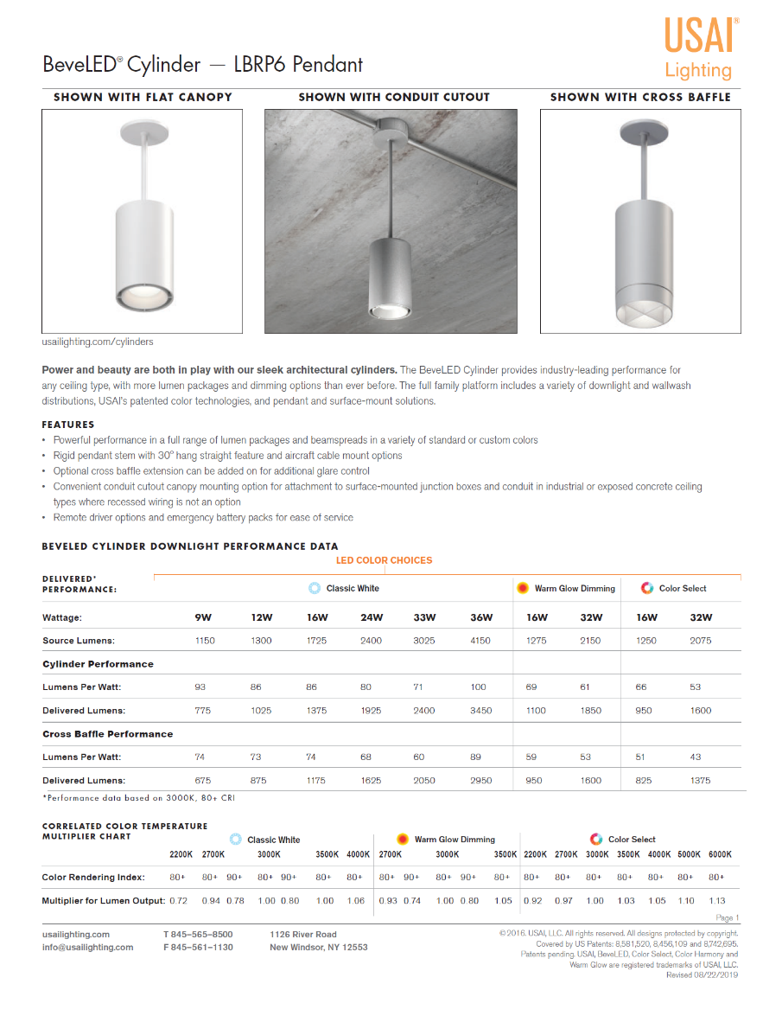

12 hours * 250 days = 3000 hours

3000 hours * 6600 W = 1,980,000 Wh

19,800,000 Wh / 1000 Wh/kWh = 19,800 kWh

19,800 kWh * $.10/kWh = $1,980

………………………………………

………………………………………

………………………………………

………………………………………

………………………………………

………………………………………

………………………………………

………………………………………

………………………………………

……………………………………………………………………………………………………………

……………………………………………………………………………………………………………

……………………………………………………………………………………………………………

1. The classroom is filled with 170 very inquisitive and hard-thinking people. Each person radiates an average of 100 W of thermal energy to the surrounding air. The walls of the room are not well insulated, and heat also leaks through the large glass windows. It is estimated that around 50 kW of heat is lost via thermal radiation and conduction through the room’s walls and large windows in wintertime. Considering the heat emitted by the lightbulbs and people inside the room and the heat lost through the windows and walls, what is the net heat rate (in kW) gained in the room? [5 points]  
      
   170 people * 100 W/person = 17,000 W

17,000 W / 1000 W/kW = 17 kW

17 kW + .66 kW = 17.66 kW

17.66 kW – 50 kW = -32.34 kW

Total of 32.34 kW lost in the winter (-32.34 kW)

……………………………………………………………………………………………………………

……………………………………………………………………………………………………………

……………………………………………………………………………………………………………

……………………………………………………………………………………………………………

……………………………………………………………………………………………………………

……………………………………………………………………………………………………………

……………………………………………………………………………………………………………

……………………………………………………………………………………………………………

……………………………………………………………………………………………………………

……………………………………………………………………………………………………………

……………………………………………………………………………………………………………

……………………………………………………………………………………………………………

……………………………………………………………………………………………………………

……………………………………………………………………………………………………………

……………………………………………………………………………………………………………

1. 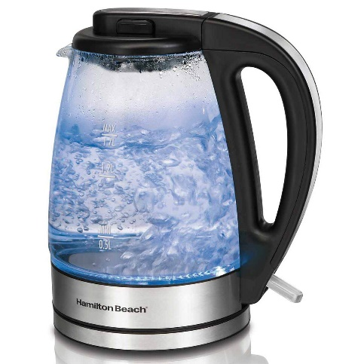1.7 liters of water is being boiled for 3 minutes in an electric kettle fitted with a 1 kW electrical resistive element. You may assume that the 1.7 liters of water has a mass of 1.7 kg. Heat is lost at a rate of 100 W via radiation and conduction through the kettle’s transparent glass wall.
   1. What is the net *heat transfer* (in joules, J)? [5 points]

3 min * 60 sec/min = 180 seconds

1 kw * 1000 W/kW = 1000 W

1000 W – 100 W = 900 W

900 W = 900 J/s

900 J/s * 180 s = 162,000 J

The net heat transfer to the water was 162,000 J ……………………………………………………………………………………………………………

………………………………………………………………………………………………………………………………………………………………………………………………………………………………………………………………………………………………………………………………………

* 1. What is the net *specific heat transfer* (in joules / kilogram, J/kg*)?* [5 points]

162,000 J / 1.7 kg = 95,294.11765 J/kg

The specific heat transfer is 95,294.11765 J/kg

……………………………………………………………………………………………………………

……………………………………………………………………………………………………………

………………………………………………………………………………………………………………………………………………………………………………………………………………………………………………………………………………………………………………………………………

1. 100 g of air inside a piston-cylinder assembly is compressed. For the compression process, it may be assumed that . The initial volume of the air is 0.08 m3 and the final volume is 0.04 m3.
   1. If the final pressure is 700 kPa, what was the initial pressure? [5 points]

Assuming po~~V~~o = pf~~V~~f

p0*.08 m^3 = 700 kPa * .04 m^3

p0 = 700 kPa * .04 m^3 / .08 m^3

p0 = 300 kPa

……………………………………………………………………………………………………………

………………………………………………………………………………………………………………………………………………………………………………………………………………………………………………………………………………………………………………………………………

* 1. How much work was required to compress the air? [5 points]

$$W= \int_{V0}^{Vf}{p* dV}= \int_{V0}^{Vf}{\frac{constant}{V}* dV}=constant\int_{V0}^{Vf}{\frac{1}{V}* dV}=constant\left[\ln\left(Vf\right)-\ln\left(V0\right)\right]$$

$$constant\left[\ln\left(\frac{Vf}{V0}\right)\right]= 700 kPa* .04 m^{3}*\ln\left(\frac{.04}{.08}\right)= -19.40812106 kPa*m^{3}$$

The work it took to compress the gas was -19.40812106 kPa * m^3